Create a script file(writing script to move the file) move.sh
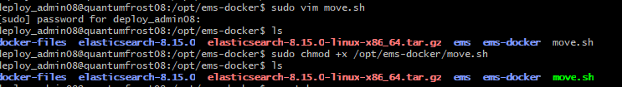

Inside the script file add the content
Sudo vim move.sh
#!/bin/bash

# Move the docker-compose.yml file from /opt/ems-docker/docker-files to /opt/ems-docker/
mv /opt/ems-docker/docker-files/crontab-file /opt/ems-docker/

~

Make the script executable:
sudo chmod +x /opt/ems-docker/move.sh

Create a cron job: set up a cron job to run this script every day at 11:51 AM
Crontab -e
Add the following line to run the script at 11:51 AM every day:

51 11 * * * /opt/ems-docker/move.sh >> /opt/ems-docker/move.log 2>&1

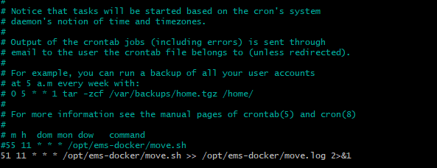

Verify the Cron Job
crontab -l

